**Project Design Phase-II**

**Technology Stack (Architecture & Stack)**

|  |  |
| --- | --- |
| Date | 03 October 2022 |
| Team ID | PNT2022TMID47211 |
| Project Name | AI-powered Nutrition Analyzer for Fitness Enthusiasts |
| Maximum Marks | 4 Marks |

**Technical Architecture:**

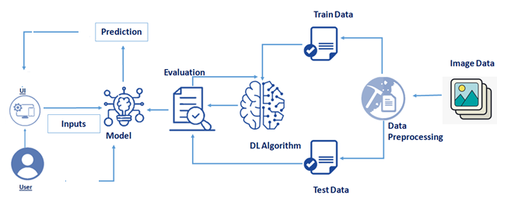

**Table-1 : Components & Technologies:**

|  |  |  |  |
| --- | --- | --- | --- |
| **S.No** | **Component** | **Description** | **Technology** |
|  | User Interface | Web UI | HTML, CSS, JavaScript |
|  | Database | Data Type, Configurations and data will be stored. | MySQL, Js etc. |
|  | Cloud Database | Database Service on Cloud | IBM DB2, IBM Cloudant etc. |
|  | File Storage | File storage requirements | IBM Block Storage or Other Storage Service or Local Filesystem |
|  | Machine Learning Model | Purpose of Machine Learning Model | ANN, CNN, RNN |

**Table-2: Application Characteristics:**

| **S.No** | **Characteristics** | **Description** | **Technology** |
| --- | --- | --- | --- |
|  | Open-Source Frameworks | Flask | Technology of Opensource framework |
|  | Security Implementations | Data protection | Authorized APIs Only |
|  | Scalable Architecture | Micro-services | Micro web application by Flask |
|  | Availability | Distributed servers | Android |
|  | Performance | High Flexibility, Quick accessibility | framework |

**References:**

[**https://ieeexplore.ieee.org/document/9824332**](https://ieeexplore.ieee.org/document/9824332)

**https://www.ijert.org/ai-based-workout-assistant-and-fitness-guide**